Jan. 31, 2024 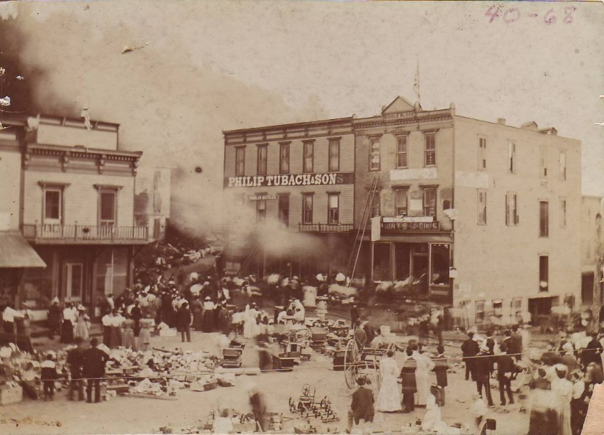

TOURING SULLIVAN COUNTY’S MUSEUM . . . while dusting

Within recent news in the Sullivan Review, there are often articles on any one of our fire company’s personnel receiving awards, a new truck that’s been purchased, an anniversary event of their existence and anything else of individual news worthy events.
Recently through the very kind consideration of Chris Kelly who was able to acquire many photographs from the sale of Sig and Ann Dehler’s estate (Chris, thank you so very much!), we found a May 1898 “Fire at Dushore”. Already included in the Museum’s collections there is a similar photograph, this one is just a bit different.
The first thing to notice is that there isn’t the monument we have today. The buildings to the right, which are Obert’s Hotel and Cole’s Hardware (then not visible would have been the first Sullivan Review office and print shop). Featured on the right is what today is the blue sided building, which is now the Sullivan Review print shop. Tubach’s had the rest of that building’s extension going towards up Turnpike Street. The smoke is obliterating the warehouse building at the railroad tracks.
Now, look at the people. The ladies are in long skirts. The young girl at the forefront has mid- calf length dress on and is faced away from the fire with concerned hands to her face. Looking towards the burning building, there appear to be many people gathered, possibly in a bucket brigade. In the middle of the street is a ‘box’ appearing thing which holds water, which is being sprayed at the front of the first building entrance way. On up Turnpike Street is someone setting up a saw horse, presumably to stop traffic coming down. A horse drawn wagon is to the far left standing calm amidst the chaos. Then in aside the horse is a pile of debris that could be the items removed from burning buildings and another pile behind the water ‘tankard’. A rope goes across behind the crowd which may have been to stop traffic going down Main Street.
No matter when, where or who is affected, a fire can debilitate anyone’s life. So that, in this case, Dushore built a fire house because of this fire. That building is now the home of today’s Sullivan Review. So whenever possible, thank your local firemen, EMTs and all first responders. They (usually volunteers for Sullivan County), work their darndest for all our benefits when an emergency of any kind takes place.
For this and more, you can contact the Sullivan County Historical Society’s Museum by phoning 570-946-5020 or emailing scpahistory@gmail.com or just stop in if you see the ‘open’ sign in the window.

